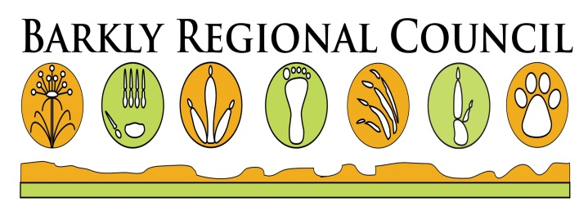

**STATEMENT of SPONSORSHIP CONFIRMATION**

We are pleased to confirm our commitment below to Barkly Regional Council as a sponsor for its Australia Day Celebrations to be held 26 January 2018.

By signing this letter I/we confirm my/ our sponsorship of both goods and or services.

I/We understand that Barkly Regional Council will rely upon my sponsorship when making expenditures, entering into contracts, and engaging in other activities for the benefit of Australia Day Activities, and recognising further that others have made and will make contributions to this celebration for like purposes. I/We accept that Barkly Regional Council will allocate this sponsorship in the manner it deems appropriate in support of the Australia Day Celebrations.

I/We hereby offer sponsorship in the sum of $ _____________________________ or services as

detailed________________________________________________________________________

which can be collected on __________________________.

*(collection of sponsorship before 20 January 2018 is encouraged)*.

Please acknowledge your acceptance of my sponsorship in accordance with the terms herein described by signing and returning a copy of this letter to me.

__________________________________ ________________________________________

Sponsor/s Signature/s

Date ______________________________

Barkly Regional Council hereby accepts and acknowledges the foregoing sponsorship and accepts its terms as of the date written.

Thank you for your support.

__________________

Barkly Regional Council