|  |  |  |
| --- | --- | --- |
| **Sponsorship**  **Category** | **Amount /** total value of sponsorship | **Benefits** |
| **Gold**  Sponsors | $800 and above | * Logo in the President’s monthly column in the *Tennant and District Times* to acknowledge support * Logo in the front pages of 2017 1st Quarter Barkly Regional Council (BRC) Magazine to acknowledge support * Allowed to bring a maximum of two company or organisation banners or promotional materials on the day * Coupon for Australia Day morning ceremony breakfast for two * Prominent recognition in the lead up to and after the event in the local newspaper, BRC community board and BRC website * Prominent recognition on the day of celebration * Prominent recognition with Australia Day Council * A Certificate of Appreciation from the Australia Day Council NT and Barkly Regional Council |
| **Silver**  Sponsors | $500 - $799 | * Thank you mention in the President’s monthly column in the *Tennant and District Times* to acknowledge support * Logo in the middle pages of the 2017 1st Quarter BRC Magazine to acknowledge support * Allowed to bring one company or organisation banners or promotional material on the day * Prominent recognition in the lead up to and after the event in the local newspaper, BRC community board and BRC website * Prominent recognition on the day of celebration * A Certificate of Appreciation from the Australia Day Council NT and Barkly Regional Council |
| **Bronze**  Sponsors | $200 - $499 | * Thank you mention in the President’s monthly column in the *Tennant and District Times* to acknowledge support * Mention in the 2017 1st Quarter BRC Magazine (maximum of 20 words) to acknowledge support * Recognition in the lead up to and after the event in the local newspaper, BRC community board and BRC website * Recognition on the day of celebration * A Certificate of Appreciation from the Australia Day Council NT and Barkly Regional Council |
| **Iron**  Sponsors | Below $200 | * Thank you mention in the President’s monthly column in the *Tennant and District Times* to acknowledge support * Mention in the 2017 1st Quarter BRC Magazine (maximum of 10 words) to acknowledge support * Recognition in the lead up to and after the event in the local newspaper, BRC community board and BRC website * Recognition on the day of celebration * A Certificate of Appreciation from the Australia Day Council NT and Barkly Regional Council |

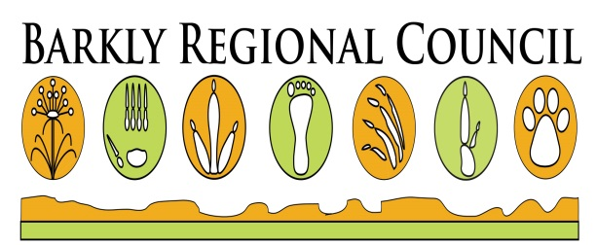

**2017 Australia Day Celebrations at Lake Mary Ann**